### Introduction

In Chicago, there's a drug problem that's hampering state security, so we're going to study data on drug victims in Chicago in order to group drug users. This will allow institutions fighting drug use in the U.S. such as federal and state and local government and the police to better know and identify the areas best able to contain this illegal activity in greater quantity and try to prevent it while using visualization and machine learning tools and even using Foursquare's API to identify the neighborhood that favors the drug market.

### Data Section

In this section, we present you the data we will work with, it is a dataset with the coordinates of the cities in the State of Chicago where the girls are found according to three characteristics, namely according to the city where the people lived, where they bought or consumed drugs and finally where their bodies were found overdosed according to the drug used and their age.

link to the data:

<https://github.com/tchala14/final/blob/master/Accidental_Drug_Related_Deaths_2012-2018.csv>

### Methodology

Our analysis consists of identifying the people who died as a result of drug abuse in the state of Chicago in the United States, to do this we use the data described, where we use pandas and numpy to treat and clean up after we use seaborn to explore the data and statistical tools to understand the data and finally we use clustering to group the deceased according to their cities in relation to their age, the places where they use drugs and the city where they were found dead.

### Result

In analyzing the data we discovered:

Men take more drugs than women.

The people who died as a result of drug abuse are generally men, as the graph below shows, ¾ of these people are men.

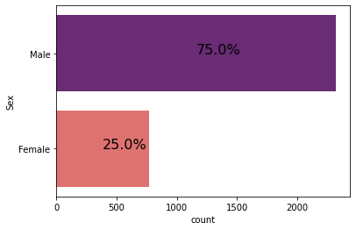

White people do more drugs than colored people.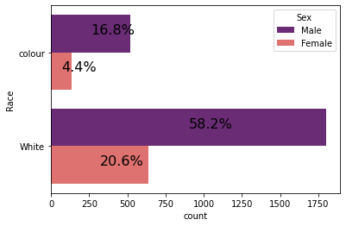

If we continue to look by gender, we go by race, and we notice that out of every 100 drug addicts found dead in the city of Chicago, 80 are white and the other 20 are people of colour, a ratio that is not too different if we analyze by gender.

We know that our study was conducted on a sample of about 3,000 individuals, which tells us that the average age of a drug addict in Chicago is 42 years old, but half of these drug addicts are under 42 years old, with 25% of the drug addicts between 15 and 32 years old, 25% between 52 and 84 years old.

We performed a clustering that groups individuals according to their age, place of death and the place where they usually use drugs, and this results in 5 clusters where we use mapping to locate them on the map.

### Conclusion

The clustering allowed us to locate the drug addicts most vulnerable to succumb to an overdose of a given drug, with 5 clusters which group together according to the similarity of the individuals succumbed following the consumption of the drug, one discovers in the 5 clusters collected a demarcation which shows a greater resistance among the young people and the coloured people and which declines with age until obtaining a greater vulnerability among the old people, one then has 5 profiles followed by a note of vulnerability with a greater vulnerability in class 0 and decreasing up to 5.